**Full Name: ____________________________**

**Class Exercise Challenge #4**

**GAME 2343/2347 and IMED 1345/2345**

**Due Date:**

After today’s lecture and hands on activities, you will need to complete the following challenge:

1. Create a Tip calculator, create a new C# script, call it “tipCalculator”, in this script, provide a field for the balance, and percentage of the tip, once you add the proper values to these fields, you should disable the cube and print the value to the Console.

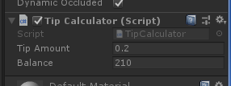



2. Toggle between the two states (checked and unchecked), you will need to take the screen shot, copy and paste it below.

3. Upload this document to eCampus before the due date.